

A GUIDE FOR HOME OWNERS

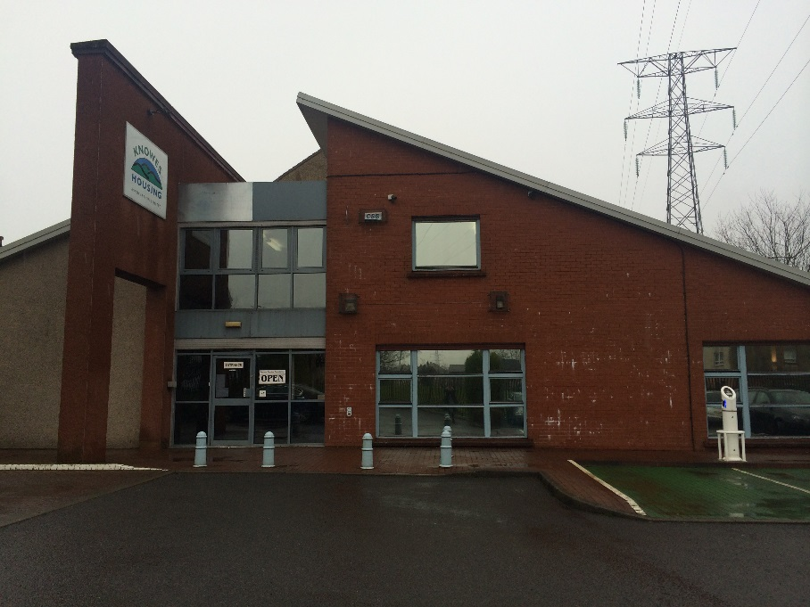

**Who Are Knowes Housing Association?**

Knowes Housing Association Limited is a non-profit making community based Association. We are registered with the Scottish Housing Regulator and are a member of the Scottish Federation of Housing Associations. Knowes Housing provides affordable housing for rent in Faifley and Duntocher.

Our prime aim is to provide good quality housing in an environment, which is responsive and affordable to those people in most need in the rented sector. The ability to achieve this aim is however subject to the number and type of houses available at any given time.

The Association has over 1000 properties. Due to the Right to Buy only a small amount of cottage type properties and four in a block remain for rent. The majority of flats are modernised with full central heating, double glazing and controlled entry.

We have over 500 owner occupiers and provide a factoring service to around 200 of those owners.

Knowes Housing Association Limited manages all the Association’s rented properties. All overheads including staff salaries and office overheads are met by the tenants’ rents. Any service given to owner occupiers must be met by you.

Knowes Housing Association Limited carries out repairs and maintenance to all communal areas in our ownership, such as landscaped areas, parking, play areas and, in some places, certain roads and footpaths. This is done on behalf of all residents. As an owner occupier, you are jointly responsible with the other owners, including Knowes Housing Association to contribute to these costs.

**The activities we carry out include:**

Estate Management:

Regular visits are carried out by Housing Officers to monitor the general appearance of the neighbourhood.

Open Space Maintenance:

Regular grass cutting is carried out during the summer, where this is appropriate.

Contract Works For Areas of Communal Responsibility:

1. Keeping lists of approved contractors.
2. Obtaining competitive tenders.
3. Supervising contracts, such as monitoring the performance of the contractor.
4. Making payments to contractors at correct time.

Factoring:

Arranging for communal repairs to be carried out, monitoring the contractor’s performance and making payments.

Issuing of accounts to owner occupiers for shared charges and collecting payment.

Arranging for a buildings insurance policy through a competitive tendering process.

**Your Responsibility as a Home Owner**

Being a home owner brings a shared responsibility for the maintenance and upkeep of the communal area of the building you live in. It is your responsibility to

* Make payment of your invoices on time
* Ensure stairways are kept clean and tidy
* If you are aware that a repair is required you contact the office to report this
* You do not cause unreasonable noise or nuisance to your neighbours
* You do not physically or verbally abuse Knowes Housing Association staff
* You allow access to staff and contractors to carry out repairs and inspections

**Information for Flat Owners**

Once you own your home it is up to you to carry out the repairs, etc. within your own flat. You are also obliged to share the costs of repairs/maintenance to any common areas within your block.

These common areas are clearly defined in your Title Deeds, which your Solicitor has a copy of and include the roof, the close, garden and common pathways.

**What is the Factoring Service?**

A factoring service is to make sure that the building you live in and the common ground around it are looked after, and the required services supplied.

The factor will:

Arrange and oversee common repairs to the property by an approved contractor, make payment to the contractor and invoice owners for their share of the cost according to the Title Deed of the property.

Carry out competitive tendering for the buildings insurance.

We will contact owners regarding major works to be carried out.

On the sale of a property a final invoice will be issued to your Solicitor for your share of costs for the factoring fee, buildings insurance and common repairs any float paid by you when your purchased the property will be deducted from this invoice.

What are common areas?

Common areas include the external structure of the block and any common garden ground that serves more than one of the flats within the block.

If you are not sure whether a repair to your property is a common repair, phone the office and we will be happy to find this out and advise you.

If necessary, a visit to your home will be arranged to determine whether the repair is common to the property.

If the repair is within a common area we will arrange for this repair to be carried out.

The main common areas are:

* The solum - the area underneath the building
* The outside walls excluding all windows, doors window and door frames and the mastic sealant between the frames and the outside walls
* The roof, chimney and any sky lights
* The attic and/or roof space
* All main water supply pipes, sewage and drainage pipes, gutters, down pipes, gas and electric mains and other pipes.

What is a Factor?

In this context a Factor is the person or company who provides the property management service, in your case this is Knowes Housing Association Limited.

If you need any information regarding factoring please visit the following website <http://www.underoneroof.scot/articles/1352/Owners___Obligations/Property_management_rules>

Repairs Deposit?

A deposit of £100.00 paid into a repairs fund is required, and will have been transferred from Scottish Homes (£30.00 at that time) to Knowes Housing Association if you were previously factored by Scottish Homes. If not the current deposit is £100.00. This is because we have to deal with repairs and pay for them before sending you the invoice. If you sell your house the deposit will be refunded less any money owing to the Association at the date of sale.

An annual fee for the factoring service is also payable. Currently this costs £132.00 per year, payable in four instalments of £33.00 each. These will be collected quarterly and will be part of your account for common repairs etc.

What do I get for my £133.00?

The factoring fee is a management fee and the Association will manage, arrange, plan and contract out common services for your property. During the year we will ensure that repairs needed to your building are seen to quickly and properly. We will also manage contracts relating to your property i.e. maintenance painter work for common areas for which you may be invoiced separately and ensure that common services are properly provided. These will be done to give value for money and you will be sent an account quarterly for your share of common works plus the factoring fee. All owners will be charged for any open space maintenance (grass cutting) which was actually carried out.

Can the Association make regulations?

**YES.** For example there could be a regulation that each person takes a turn to clean the stairs, etc. It is your responsibility to take your turn or to arrange that such duties be carried out on your behalf.

Will I have a say in things?

**YES.** There will either be a meeting to discuss major common repairs (i.e. exceeding a cost of £700.00 per house) etc. which you can attend or we will send you a letter about it.

The Association also has places on the Management Committee, which meets each month. You can take out a share for £1.00. This will allow you to vote at the AGM and stand for election to the Management Committee. Owners are also invited to participate in Focus Groups.

If you wish to become a Share Member, find out more about becoming a committee member and/or participate in our Focus Groups please contact our Corporate Services Officer, Amy Sweeney on 01389 877752, option 5.

What about Insurance?

As with most factoring services for blocks of flats it is compulsory that you take out common BUILDINGS insurance. This is arranged for you by Knowes Housing Association. To prevent the payment of two buildings insurance premiums you must advise your mortgage lender of this mandatory arrangement. It is easier to deal with one insurance company for the whole block and fire damage, roof repairs, etc. can be dealt with much more quickly this way. Insurance premiums are also cheaper with this arrangement. If you are in any doubt as to whether you are included in the Association’s block insurance policy contact the office.

If you require a claim form please contact Maureen MacConnell, Finance Officer at the office – telephone number 01389 877752 option 4.

What about other Insurance?

It is up to you to make your own arrangements for any other insurance e.g. house contents insurance, life insurance, mortgage protection insurance and endowment insurance. These are not covered by the factoring service. The Association does offer a home contents insurance scheme and leaflets are available from the office.

What happens if I sell my flat?

The new owners will still have to take part in the factoring service if the flat was originally purchased after July 1988. Your Solicitor must contact us as soon as possible if you sell your property. There is a charge for the information they require and the sooner contact is made the less the charge will be. This will allow us to apportion your final account, refund your repairs deposit and carry out a change of ownership to our record.

What if I let my flat to someone else?

You will still have to pay the charges. If you move you must tell us in writing stating who is staying in the flat and each time there is a change. You must also give us your forwarding address so we can contact you about repairs etc.

What if your share of a repair costs more than £700.00?

Knowes Housing Association will contact you to discuss the repair work required. This will either take the form of a meeting for those concerned or alternatively, you will be sent a letter detailing the repair work and advising you of the cost.

This figure is reviewed annually to take into account increasing costs.

What happens if an emergency/urgent repair is needed?

The Association will deal with this even if it is over £700.00 and owners will be notified as soon as possible.

**About Common Charges**

The office, as detailed below, will issue invoices for common charges quarterly.

|  |  |  |
| --- | --- | --- |
| Date of Issue | Contents of Invoice: | |
| April | 3 Months landscape maintenance | |
|  | 3 months factoring fee | |
|  | 3 months buildings insurance | |
|  | Common repairs and planned maintenance | |
|  |  | |
| July | 3 months landscape Maintenance | |
|  | 3 months factoring fee | |
|  | 3 months buildings insurance | |
|  | Common repairs and planned maintenance | |
|  |  | |
| October | 3 Months landscape maintenance | |
|  | 3 months factoring fee | |
|  | 3 months buildings insurance | |
|  | Common repairs and planned maintenance | |
|  | |  | |
| January | | 3 Months landscape maintenance | |
|  | | 3 months factoring fee | |
|  | | 3 months buildings insurance | |
|  | | Common repairs and planned maintenance | |

In most cases cottage and 4 in a block owners will only receive an invoice bi-annually in April and November.

An administration charge (to cover costs such as staff time, stationery, postage, etc.) is added to each account based on 15% of the total value of the items charged subject to a minimum of £5.00 and a maximum of £50.00. Flat owners who are part of the factoring scheme are exempt from this administration charge.

In an attempt to keep administration fees as low as possible you will not be contacted if a repair item is less than £700.00 per house, except where an insurance claim is likely. If an individual item exceeds £700.00 we will write and advise you of the estimated cost.

The Association reserves the right to review these amounts from time to time and you will be notified of any changes.

**Payment of Invoices**

Payment of invoices should be made within 21 days of receipt. Payment can be made by setting up a bank standing order, internet banking, our customer portal or by phoning the office Monday to Friday, 9am to 4.45pm and making payment using a debit or credit card.

Any queries concerning invoices should be raised with us as soon as possible to avoid reminders being issued. Owners who anticipate having difficulty making a payment should contact the Finance Section upon receipt of the invoice to discuss a repayment plan.

Remember the Association needs you to make payment promptly. The Association has already paid for the work carried out on your behalf using income from rent paying tenants. The Association will instruct our Solicitor to raise court action for recovery of unpaid debts. You will also be charged for all expenses incurred by the Association. Please ensure you keep all your invoices as the Association will charge owners for any duplicates issued.

**Changes in Ownership and**

**Apportionment of Charges**

If you are selling your home you or your Solicitor must notify the Association of the date of sale and the name of the new owners. This will allow an apportionment of charges due at the time of sale to be issued. A refund of the repairs deposit paid may also be due to the selling owner.

Repairs

Repairs to the common areas on the estate (i.e. play areas, retaining walls etc.) or communal repairs to property (i.e. roof areas) or communal TV aerial repairs will be carried out on your behalf by Knowes Housing Association Limited. You will be invoiced for your share of this work. As a factored owner you are entitled to request that we carry out repairs to any common parts of your close or external areas, the cost of these repairs will be recharged to you in accordance with the divisors set out in your title deeds. The association as factor will also carry out regular maintenance and repairs to keep the property in a safe and well maintained condition. As a non-factored owner we will carry out repairs to common parts of jointly owned properties such as four in a block flats but we will not carry out repairs specific to your property.

Alterations to property

You must obtain Knowes Housing Association’s consent if you intend to carry out alterations to your home. As a general guideline you should notify the Association of external alterations (e.g. a porch, garage, or an extension) and internal alterations (removal of structural walls, installation of double glazing).

You must also contact West Dunbartonshire Council to ascertain whether or not planning permission and/or a building warrant is required.

Rights of access

Knowes Housing Association may require access to your property to carry out necessary work on an adjoining property still in its ownership. Similarly access may be required by you to Knowes property. Except in the event of an emergency, arrangements for access should be sought in advance. Any damage incurred must be made good by the party exercising their right of access.

If I have a query once I have bought my flat who should I contact?

Initially you should contact your Solicitor.

If you have any queries regarding repair work, landscape maintenance, etc. you should contact Knowes Housing Association staff at the office.

Neighbourhood disputes/anti-social behaviour

You may contact Knowes Housing Association – the Housing Management Team - who will be able to advise you on what remedies are available to you. Also there is an anti-social hotline number provided by West Dunbartonshire Council - 01389 772048 which you may also contact.

Dog fouling

For problems with dog fouling in the area please contact the dog wardens at West Dunbartonshire Council - on 01389 772090

Benefit help with common charges

Many owners are entitled to benefit help from the Department of Works & Pensions (DWP) with payment of most of the common charges and insurance.

If you are on the following benefits please check with your local DWP office

* Income Support
* Income Based Job Seekers Allowance
* Pension Credit
* Universal Credit

If you think you might qualify, contact your local DWP office as soon as possible. You will need to provide them with proof of the charges so keep your invoices in a safe place. If you qualify for payment this will be added on to your weekly paid benefit and you will then be responsible for making payment to us.

Debt advice

If you cannot pay due to financial difficulties you may wish to discuss this matter, and any other financial matters with Citizens Advice Bureau 0800 484 0136.

You can also contact the following agencies for help and support –

Money Advise Scotland (MAS) 0141-572-0237

Consumer Credit Counselling Service (CCCS) 0800 138 1111

National Debt line 0808 808 4000

For more useful contacts in the area please see our website at [www.knowes.org](http://www.knowes.org) or ask for a copy of our booklet ***“Taking a wider view – a guide to useful services in Faifley”.***

If you are a property owner of a factored property any complaints you may have relating to the provision of our factoring service should, in the first instance, be made by contacting a member of staff at the office. Your complaint will be investigated and dealt with in accordance with our complaints procedure and you will be informed of the outcome. Should you remain unhappy with the outcome you can then refer the matter to the:-

**Housing and Property Chamber**

**First-tier tribunal for Scotland**

**20 York Street**

**GLASGOW**

**G2 8GT**

**Telephone: 0141 302 5900**

[](http://www.customerserviceexcellence.uk.com/default.asp)

**(Revised July 2022)**

|  |
| --- |
| **Registered Office**  Knowes Housing Association Ltd.  10 Field Road, Faifley, Clydebank G81 5BX  Email: [info@knowes.org](mailto:info@knowes.org)  Website: [www.knowes.org](http://www.knowes.org)  Telephone: 01389 877752  ***Knowes Housing Association Ltd is a charitable organisation registered under Scottish Charity No: SCO27466***  ***Registered with the FCA under the Co-operative and Community Benefit Societies Act 2014 (No: 2518R9s) & within the Scottish Housing regulator No: HEP300***  ***Property Factors Registration No: PF00020***  ***VAT Registration No: 703 787032*** |